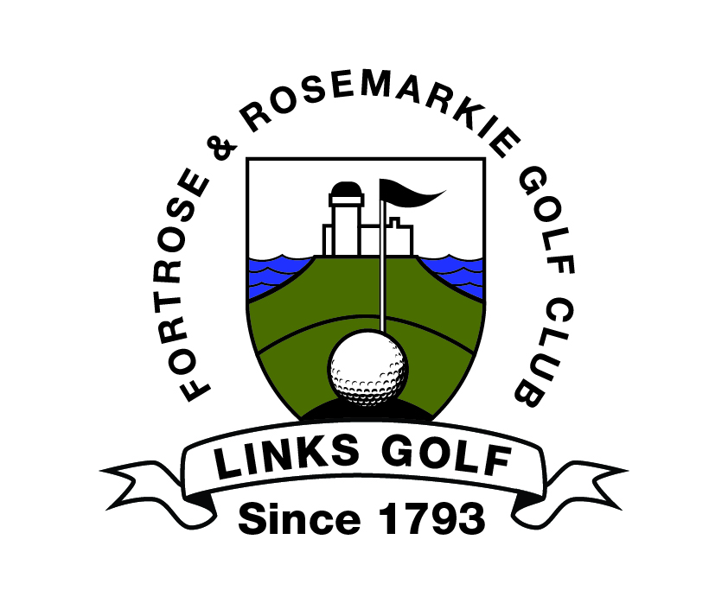

FORTROSE & ROSEMARKIE GOLF CLUB
OPEN AMATEUR TOURNAMENTS
2020
  DATE OF  OPEN | OPEN  COMPETITION | CLOSING  DATE | MEMBER ENTRY  [Per Person] | VISITORS ENTRY  [Per Person]
22nd March 2020 | OPEN TEXAS SCRAMBLE | 16th March 2020 | £10.00 | £14.00
18th/19th  April 2020 | BLACK ISLE OPEN FOURSOMES  [36 Hole Qualifying]  Top 4 Scratch & Top 4 Handicap Qualify for the Sunday Matchplay Stages | 13th April 2020 | £18.00 | £25.00
2nd May 2020 | THE LADIES BLACK ISLE  18-HOLE STROKE PLAY OPEN | 27th April 2020 | £10.00 | £15.00
3rd May 2020 | OPEN MIXED GREENSOMES [18 Holes] | 27th April 2020 | £10.00 | £14.00
14th May 2020 | SENIOR GENTS STABLEFORD OPEN [50+] | 5th May 2020 | £10.00 | £15.00
16th May 2020 | THE 3-BALL BETTER BALL OPEN | 11th May 2020 | £10.00 | £15.00
27th June 2020 | OPEN TEXAS SCRAMBLE | 22nd June 2020 | £10.00 | £14.00
3rd July 2020 | JUNIOR BOYS & GIRLS OPEN | 29th June 2020 | £6.00 | £8.00
14th July 2020 | 3-LADY TEAM OPEN | 29th June 2020 | £10.00 | £13.00
16th July 2020 | SENIOR GENTS STABLEFORD OPEN [50+] | 6th July 2020 | £10.00 | £15.00
18th July 2020 | MEN’S BLACK ISLE OPEN [36 Holes] | 13th July 2020 | £20.00 | £30.00
6th August 2020 | SENIOR GENTS STROKE PLAY OPEN [50+] | 27th July 2020 | £10.00 | £15.00
8th August 2020 | FOUR BALL BETTER BALL OPEN [18 Holes] | 3rd August 2020 | £15.00 | £20.00
9th August 2020 | THE KELLY OPEN FOURSOMES [18 Holes] | 3rd August 2020 | £15.00 | £20.00
11th August 2020 | SENIOR LADIES STABLEFORD OPEN [50+] | 3rd August 2020 | £10.00 | £15.00
5th September 2020 | GENTS 18-HOLE STROKE PLAY OPEN | 31st August 2020 | £12.00 | £20.00
3rd October 2020 | OPEN TEXAS SCRAMBLE | 28th September 2020 | £10.00 | £14.00
11th October 2020 | GENTS 18-HOLE STROKE PLAY OPEN | 5th October 2020 | £12.00 | £20.00

Competition/s _____________________________________________ Date _________________________

For the Seniors Gents (50+) Opens, age at 14th May, 16th July and/or 6th August 2020 ____________________

Name of Entrant/s _________________________________________ Handicap/s ___________________

Address ____________________________________________________ CDH Number __________________

Telephone/Contact Number ____________________ Home Club ________________________________

e-mail address [if applicable] _______________________________________________________________

Please circle preferred starting time: 07.30 to 08.30 08.30 to 09.30 09.30 to 11.00

11.00 to 12.00 12.00 to 13.00 13.00 to 14.00

14.00 to 15.30 17.00 to 18.00 (Senior Opens Only)

No refunds will be given once the draw has been made.

Entry forms are to be returned to: - The Match & Handicap Secretary,
Fortrose & Rosemarkie Golf Club, Ness Road East, Fortrose, Ross-Shire, IV10 8SE

To enter by e-mail please send the relevant details to secretary@fortrosegolfclub.co.uk - If you are entering by e-mail the entrance money must be forwarded immediately after being entered to the address above.

BOOK YOUR GOLF ONLINE THROUGH THE CLUB WEBSITE AS A QUICKER ALTERNATIVE

http://www.brsgolf.com/fortrose/opens_home.php

